NLP Lab 3: Word Embeddings & Foundational Classifiers

Module 1: Continuous Word Embeddings (Word2Vec Skip-Gram)

1.1 Theoretical Foundations

From Discrete to Continuous Representations
Traditional representations (such as One-Hot Vectors or Bag of Words) treat words as discrete, orthogonal entities. In a One-Hot encoding scheme of vocabulary size 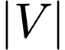, every word is represented as a high-dimensional vector with a single 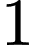 and 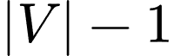 zeros:
- Drawback 1 (High Sparsity): As  grows into hundreds of thousands, vectors become computationally inefficient.
- Drawback 2 (Zero Semantic Similarity): The dot product 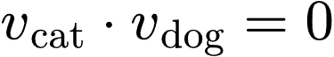. The model cannot infer that "cat" and "dog" share semantic context.
Word Embeddings project words into a dense, continuous vector space 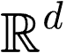 (where 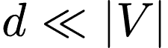, typically 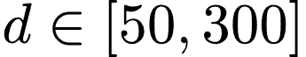). In this space, words with similar contextual distributions lie close to each other.

The Skip-Gram Architecture
The Skip-gram model learns embeddings by predicting surrounding context words 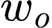 given a target center word 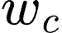 within a sliding window :
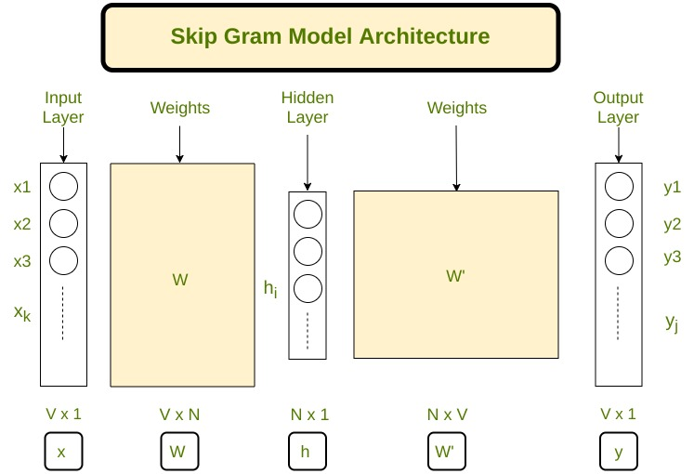

- Parameters:
  - 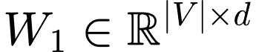: Input-to-hidden weight matrix (The Embedding Matrix where row is the vector for word ).
  - 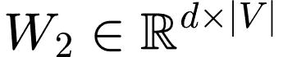: Hidden-to-output weight matrix.
- Forward Pass Math:
Given a center word index , its hidden representation is 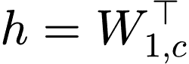. The raw output scores (logits) for all words in the vocabulary are calculated as:
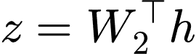
Applying the Softmax function yields the predicted probability distribution over the vocabulary:
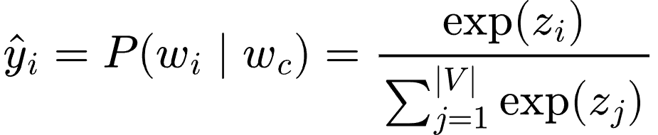
- Loss Function (Cross-Entropy):
For a true context word index , the loss 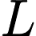 is:
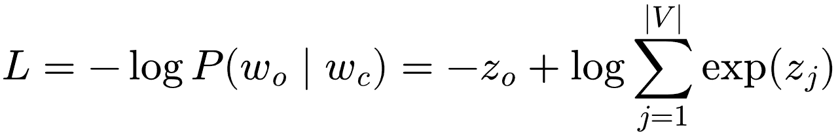
- Gradients and Optimization:
The gradient with respect to output score 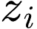 evaluates to:
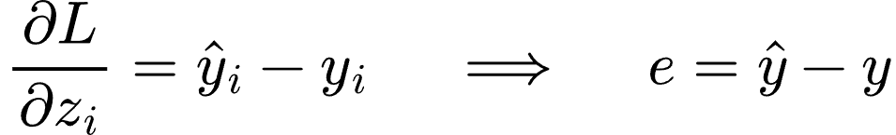
Where is the one-hot target vector for the context word. Weights are updated via Stochastic Gradient Descent (SGD):

1.2 Code Walkthrough & Implementation Details
1. Optimization Shortcut (Matrix Lookup vs. Matrix Multiplication)
In theory, the hidden layer computes 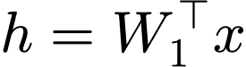. Because is a one-hot vector with a  at index , multiplying 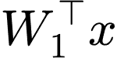 yields row of 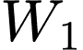.
- In Code: We skip  matrix multiplication and directly index W1[center_id].
- Similarly, for the error vector 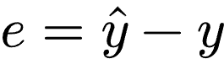, we compute y_pred and subtract 1.0 directly from y_pred[context_id].
2. Softmax Numerical Stability
When computing 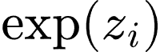, large values of  can cause numeric overflow (NaN).
- Fix: Subtract 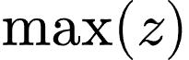 from all elements of before exponentiating:
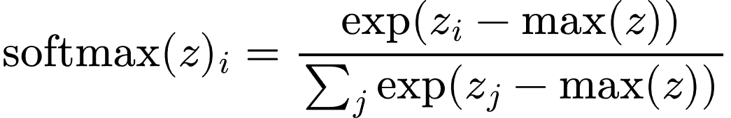

Module 2: Generative Text Classification (Naive Bayes)

2.1 Theoretical Foundations

Bayes' Theorem for Classification
Naive Bayes is a generative model. Given a document 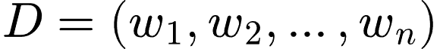 and a set of classes 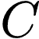, it calculates the posterior probability 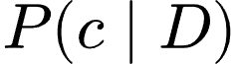 for each class 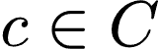:
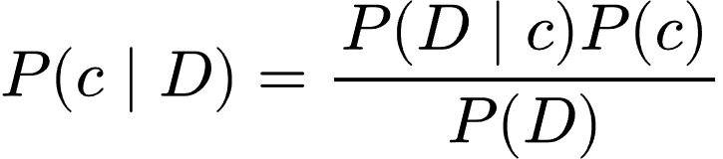
Since 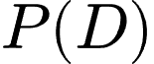 is constant across all classes during prediction, we maximize the numerator:
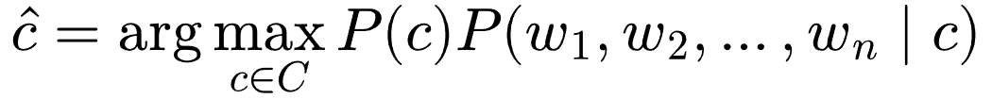

The "Naive" Independence Assumption
Naive Bayes assumes that the occurrences of words are conditionally independent given the class label :
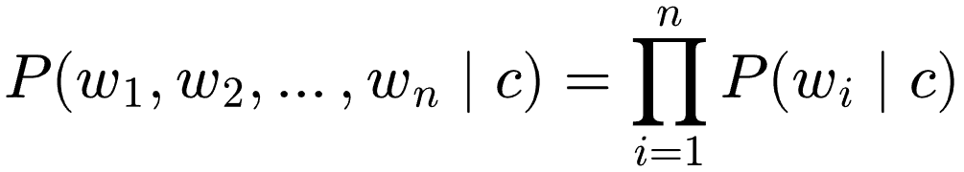
Thus, the classification rule becomes:
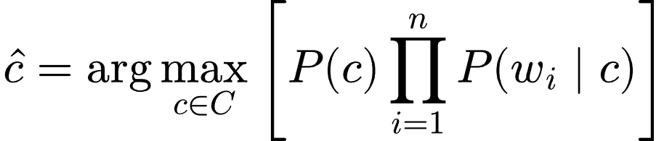

Parameter Estimation & Laplace Smoothing
- Prior Probability:
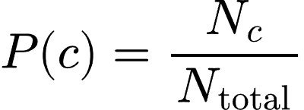
(where 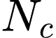 is the number of documents in class )
- Likelihood with Laplace (Add-1) Smoothing:
If a word 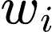 never appears in class during training, 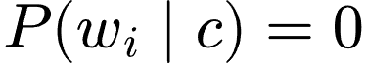, causing the entire product to become zero. We apply Laplace smoothing:
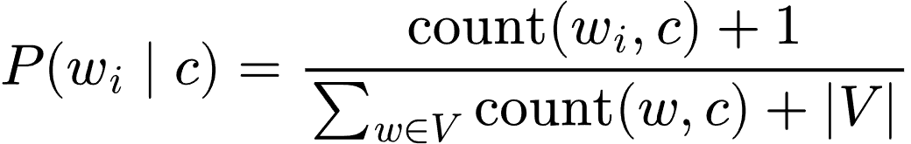

Log-Space Computation
Multiplying many probabilities 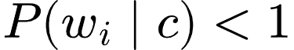 causes floating-point underflow. We transform calculations into log-space (converting multiplication to addition):
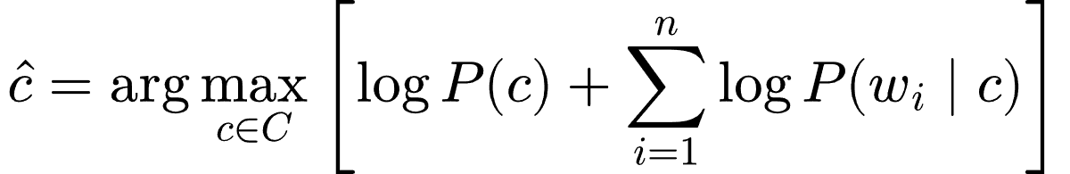

2.2 Code Walkthrough & Implementation Details
- Training Phase:
  - Iterate through documents to collect global term counts per class word_counts[label][word].
  - Compute log priors: log_priors[c] = np.log(classes[c] / total_docs).
  - Precompute log likelihoods for every word in the vocabulary using the smoothed denominator total_words_in_c + V_size.
- Prediction Phase:
  - Initialize total score for class with log_priors[c].
  - Iterate through test words, adding log_likelihoods[c][word]. Unseen vocabulary words are skipped.
  - Select the class with the maximum score using max(scores, key=scores.get).

Module 3: Discriminative Text Classification (Logistic Regression)

3.1 Theoretical Foundations

Generative vs. Discriminative
Unlike Naive Bayes (which models the joint distribution 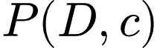), Logistic Regression is a discriminative model. It models the conditional probability  directly by learning decision boundaries.

Model Formulation
For binary classification (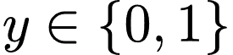), given a document feature vector 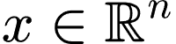:
- Linear Combination:
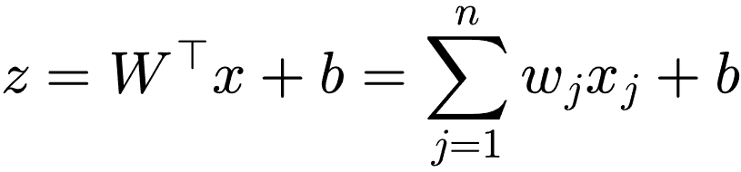
- Sigmoid Activation Function:
To map 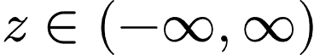 to a valid probability 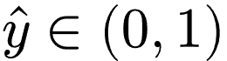:
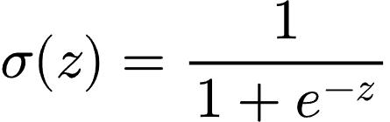

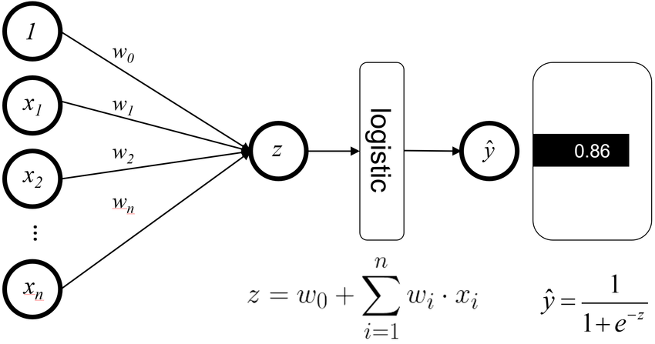

Binary Cross-Entropy Loss
For a dataset of samples, the objective function (Log Loss) is:
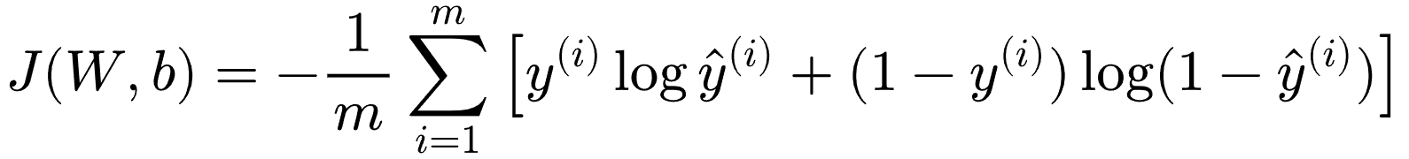

Gradient Descent Updates
Partial derivatives with respect to parameters:
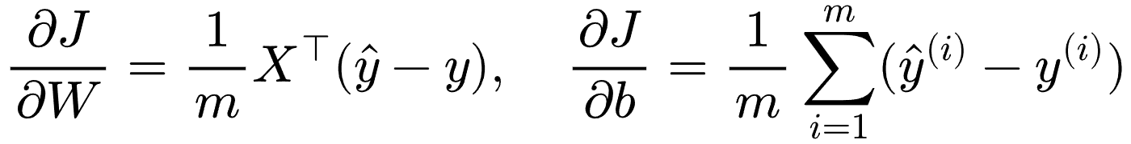
Gradient updates applied iteratively with learning rate :
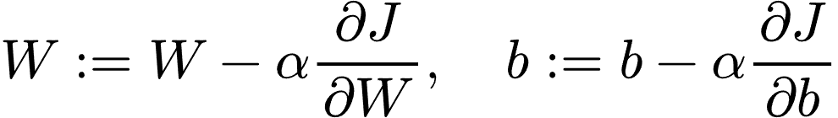

3.2 Code Walkthrough & Implementation Details
- Vectorization: Features 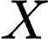 are structured as an 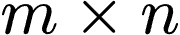 matrix ( documents, vocabulary size).
- Linear Projection: Computed in NumPy as z = np.dot(X, weights) + bias.
- Gradient Calculation:
- Python
dw = (1 / m) * np.dot(X.T, (y_pred - y))
db = (1 / m) * np.sum(y_pred - y)

- This vectorized update processes all training instances simultaneously.

Module 4: Text Vector Aggregation & Sequence Limitations

4.1 Theoretical Foundations

Mean Embeddings vs. TF-IDF Weighted Embeddings
Logistic Regression requires a fixed-size vector per document. To convert word-level embeddings into a document vector 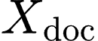, two common strategies are used:
- Unweighted Mean Embedding ("Neural Bag of Words"):
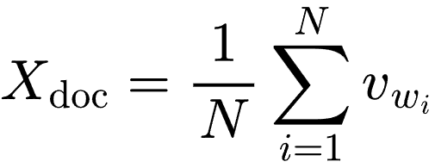
- TF-IDF Weighted Average Embedding:
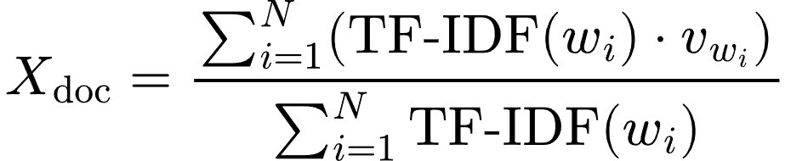
- Advantage of TF-IDF Weighting: Reduces the impact of high-frequency, non-informative words (e.g., "is", "the"), giving more weight to salient terms (e.g., "terrible", "excellent").

4.2 The "Bag of Words" Structural Limitation
A fundamental limitation of any vector aggregation scheme (Mean or TF-IDF weighted) is that it lacks sensitivity to word sequence order.

Mathematical Proof of the Anagram Dilemma
Consider the two sentences:
- 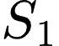: "the dog bit the man"
- 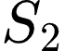: "the man bit the dog"
Let .
- Term Frequencies (TF):
- Inverse Document Frequency (IDF):
Since IDF is computed over the entire corpus , 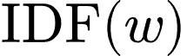 is identical for both sentences.
- Aggregation Equivalence:
Because vector addition is commutative (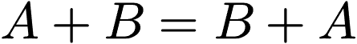):
Core Takeaway: Because 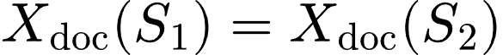, any downstream linear model (such as Logistic Regression or SVM) will produce identical probabilities for both inputs, despite their opposing meanings. To preserve word order, models must process sequences recurrently (e.g., RNNs, LSTMs) or via position-encoded attention mechanisms (e.g., Transformers).

Summary Comparison Matrix
Property | Naive Bayes | Logistic Regression | Word2Vec (Skip-gram)
Model Family | Generative | Discriminative | Unsupervised Self-Supervised
Optimization Target | Joint Likelihood  | Conditional Likelihood  | Neighborhood Likelihood 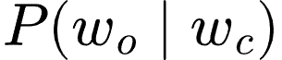
Primary Input | Sparse Word Counts | Sparse BoW or Dense Embeddings | One-Hot Word Index
Computational Speed | Extremely Fast (Closed-form counts) | Moderate (Iterative Gradient Descent) | High Compute Cost (Iterative over text corpus)
Handling Unseen Words | Handled via Laplace Smoothing | Handled via zero features or zero vectors | Handled via OOV vector strategies
Preserves Word Order? | No | No (when using BoW/Averaging) | Partially (within context window )

